Build Python Code

|  |  |
| --- | --- |
| Date | 8 November 2022 |
| Team Id | PNT2022TMID07703 |
| Project Name | AI-POWERED NUTRITION ANALYZER FOR FITNESS  ENTHUSIASTS |
| Maximum Marks | 4 MARKS |

**Importing Libraries**

The first step is usually importing the libraries that will be needed in the program.

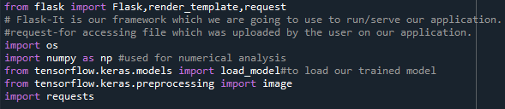Importing the flask module into the project is mandatory. An object of theFlask class is our WSGI application. Flask constructor takes the name of thecurrent module ( name ) as an argument Pickle library to load the model file.